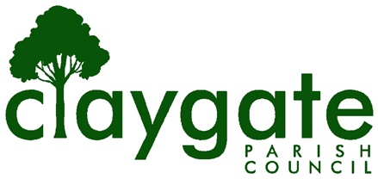
APPLICATION FOR CO-OPTION AS A PARISH COUNCILLOR
Thank you for your interest in becoming a Parish Councillor. Please provide the information below to assist the Council in making its decision.
Full Name and Title
Home Address
Telephone
Email Address
Please explain why you wish to become a Parish Councillor:

Please outline any skills, experience, or community involvement that you feel would assist the Council:

Signature

Proposer and Seconder
 | Proposer | Seconder
Name
Address
Signature | ..…………..…………………………. | ………………………………………………..

Co-option Eligibility Form

I am a British, Irish or qualifying Commonwealth Citizen, or a citizen of any other member state of the European Union. YES / NO
I am 18 years of age or over. YES / NO
I am registered as a local government elector for the parish. YES / NO
I have occupied land or premises in the parish for the previous 12 months. YES / NO
My principal or only place of work has been in the parish for the previous 12 months. YES / NO
I have lived in the parish or within three miles of it for the previous 12 months. YES / NO
Signature
Date
All completed applications and eligibility forms must be received by the Parish Clerk (clerk@claygateparishcouncil.gov.uk) by 5.00pm on Friday 11 September 2026.
Or posted to Parish Clerk, Claygate Parish Council, Claygate Village Hall, Church Road Claygate KT10 0JP (If delivering by hand the post box is outside at the front of the Village Hall).

