
“It’s ok not to be ok”
“It’s not weak to speak”

Every 40 seconds someone in the world takes their own life
75% of mental illnesses start before a child reaches their 18th birthday and 50% of mental health problems in adults take root before the age of 15. Many young people struggle to understand their own feelings and don’t know how to talk about them. This can lead to them suffering in silence, without the help they need. We want to change that and let young people know ‘it’s ok not to be ok’.
We believe that the treatment available for those suffering with mental illness is severely limited because of gross under-funding, and there could, and should be more effective approaches to prevention, diagnosis and treatment. By helping to change this, we hope that other families might avoid the unnecessary and tragic loss of a loved one in the way that the Dear family experienced last year.
The Grace Dear Trust is a mental health charity we set up after losing our daughter and sister, Grace, to suicide aged just 27 in February 2017. Our aim is to help save the lives of other young people suffering with mental health issues. Grace had been suffering with depression and anxiety from the age of 13, but hadn’t felt she could reach out to anyone to help her make sense of her feelings.
Not knowing why, she suffered in silence for many years. Eventually when Grace spoke out we tried to give the best help possible, but unfortunately it was too late.

Get Connected
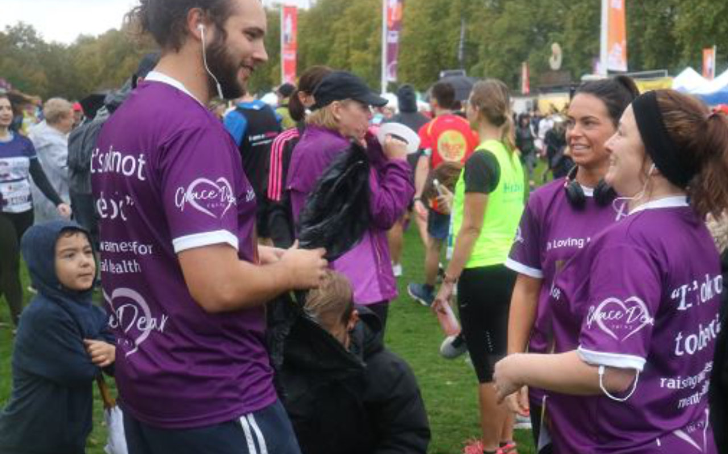
Support Us
Help and Support
“We want to raise awareness amongst school children, giving support to those who need it and preventing others from suffering so long in silence. We do this by funding seminars in schools, where guest speakers help young people understand the importance of mental well‐being.
We want to fund counsellors to visit schools, giving young people the help they need promptly and in an environment that isn’t intimidating. We also want to create a local network of professionals that young adults can reach out to.”
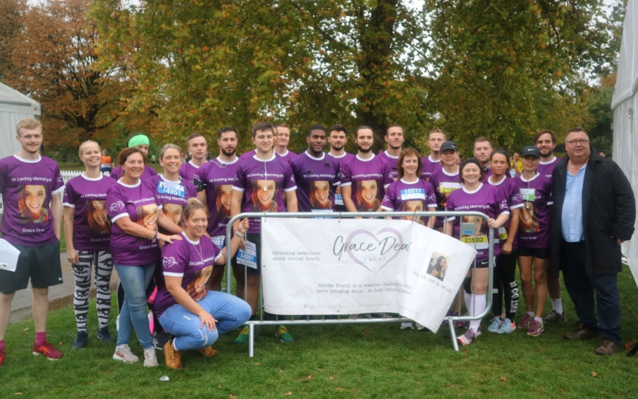
(Written by Graham, Karen, Jake, Rhys and Hope) Follow us on Instagram

