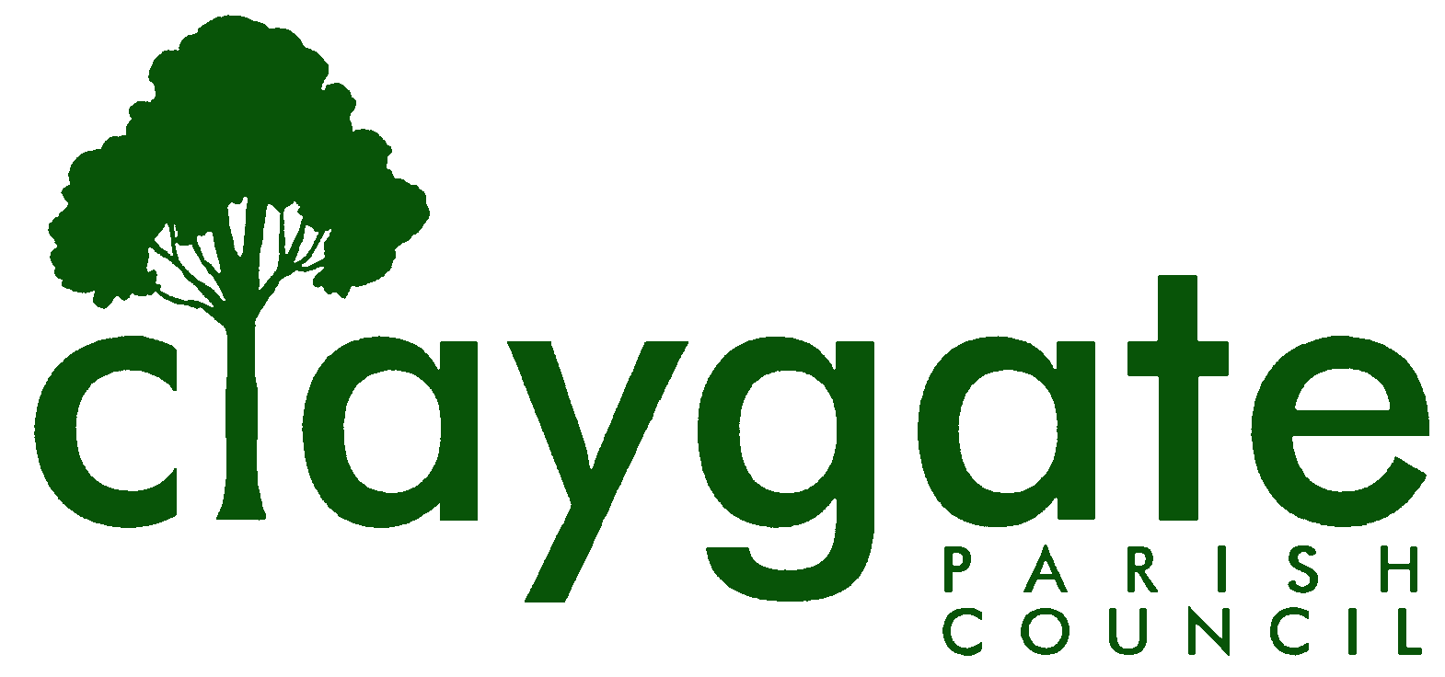
Dawn Lacey – Parish Clerk & RFO

Claygate Parish Council

Claygate Village Hall

Church Road

caring for Claygate Village Claygate

Surrey KT10 0JP

Tel: 07741848719

Email: clerk@claygateparishcouncil.gov.uk
Website: www.claygateparishcouncil.co.uk

DRAFT 28th October 2025

Minutes of the Planning Committee of Claygate Parish Council held on Thursday 23rd October 2025 at 7.30pm at Treetops Pavilion, Recreation Ground, Church Road, Claygate

Present: Cllr Collon (Chair), Cllr Holt, Cllr Bray, Cllr Burns and Cllr Ellis
In attendance: Dawn Lacey (Parish Clerk & RFO)
Non-Voting Advisor: Vanessa Relleen
EBC Cllr Mike Rollings, SCC Cllr Andy Burton, Cllr French and 2 members of the public
1. Apologies for absence.
Apologies from Cllr Sheppard and also Non-Voting Advisor John Bamford.
The absence of Cllr Herbert and Cllr Bingham was noted.

2. Declarations of Interest on Items on the Agenda.

Cllr Holt declared an interest on Item 8 – Planning Application 2025/2258, and would therefore not take part in discussion on this application.

3. To confirm the minutes of the meeting held on Thursday 25th September 2025.

Cllr Collon went through several adjustments to the minutes.
These were proposed by Cllr Collon and seconded by Cllr Holt. Carried unanimously.

These were then signed and dated by Cllr Collon.

4. To review actions from the previous meeting.

These have all been completed.

5. To answer any questions from members of the public.

None.

6. To review any planning correspondence, notification of applications and outstanding results and agree any action required.

None.

7. To report on Applications Decided, and Appeals Lodged and Decided since last meeting and agree any action required.

Nothing to discuss.

8. Discuss planning applications from Elmbridge Borough Council (EBC) Weekly Planning Lists (https://www.elmbridge.gov.uk/planning) for the following weeks and agree responses required: w/e 26th September, 3rd, 10th and 17th October.

Please see attached letters to EBC T Plan (Appendix 1).

9. To receive an update on the Cloudy IT Systems and agree any action required.

Cllr Bray reported that Steve Walker from Cloudy IT had confirmed that they are still working on making sure everything is ready before putting the product on the market. It was agreed to keep this item on the agenda for the next few meetings.

ACTION – Clerk

10. To discuss if there are any updates on the proposed Hook Park Development and agree any action required.

There is currently nothing new to report and it was agreed that this item remains on the agenda moving forward.

ACTION – Clerk

11. To receive a report on EBC’s East Area Sub Committee Meeting and agree any action require.

In the absence of Cllr Herbert, Cllr Bray agreed to look into seeing if there was anything to report and he would circulate anything of relevance to the Councillors.

ACTION – Cllr Bray

12. To receive a report on EBC’s Planning Committee Meeting, including the decision on application 2025/1386 (Land North of Raleigh Drive), and agree any action required.

Cllr Collon said that he had attended the meeting and spoken against application 2025/1386. Permission had been granted by 7 votes to 3, with 5 abstentions. There were a number of matters that concerned him:
  - The PCC objections had been submitted in June, but had not been referred to in the officer’s report for the September meeting, and (in the case of the green belt argument) referred to wrongly in the report for the October meeting;
  - Although arguments on highway safety had rightly not been allowed at the October meeting, the PCC arguments on highway safety had not been considered at the September meeting;
  - Officers had advised that green belt arguments should not be resumed at the October meeting, but the decision on green belt grounds had been overturned without any discussion;
  - The decision, which should have been made exclusively on the basis of planning law and policy, had been strongly influenced by predetermined views on the possible costs of an appeal.
Cllr Collon invited Cllr Rollings to comment. He said that members of the EBC Planning Committee had been advised that the reasons they had given for refusing permission at the September meeting could not in law be supported. If they repeated them and the applicants appealed, EBC would lose the appeal, and be liable for the costs. They had no alternative but to reverse their earlier decision.

After discussion, it was agreed that the only satisfactory way of ensuring, in the case of important applications going to the Planning Committee or East Area Sub-Committee, that Councillors were fully aware of the arguments of CPC, would be to ask for a meeting with the ward Councillors at which the arguments could be discussed. This would certainly be the case when the full application for the Raleigh Drive development was submitted.

Cllr Bray and Cllr Burns were invited to get in touch with the SCC as Highway Authority to explain the CPC concerns about highway safety in advance of the full application.

Cllr Herbert joined the meeting at 8.20pm.

13. To discuss any Communication of Key Decisions to Residents and agree any action required.

None.

14. To review any Compliance Issues in Claygate and agree any action required.

None.

15. To discuss any Licence Applications.

None.

16. Matters for information purposes only.

None.

17. Date of the next meeting 7.30pm Thursday 20th November, Treetops Pavilion, Church Road, Claygate KT10 0JP.

MEETING: Claygate Parish Council, Planning Committee
VENUE: Treetops Pavilion, Recreation Ground, Church Road, Claygate
DATE: Thursday 23rd October 2025
TIME: 7.30pm

Signed: Date:

