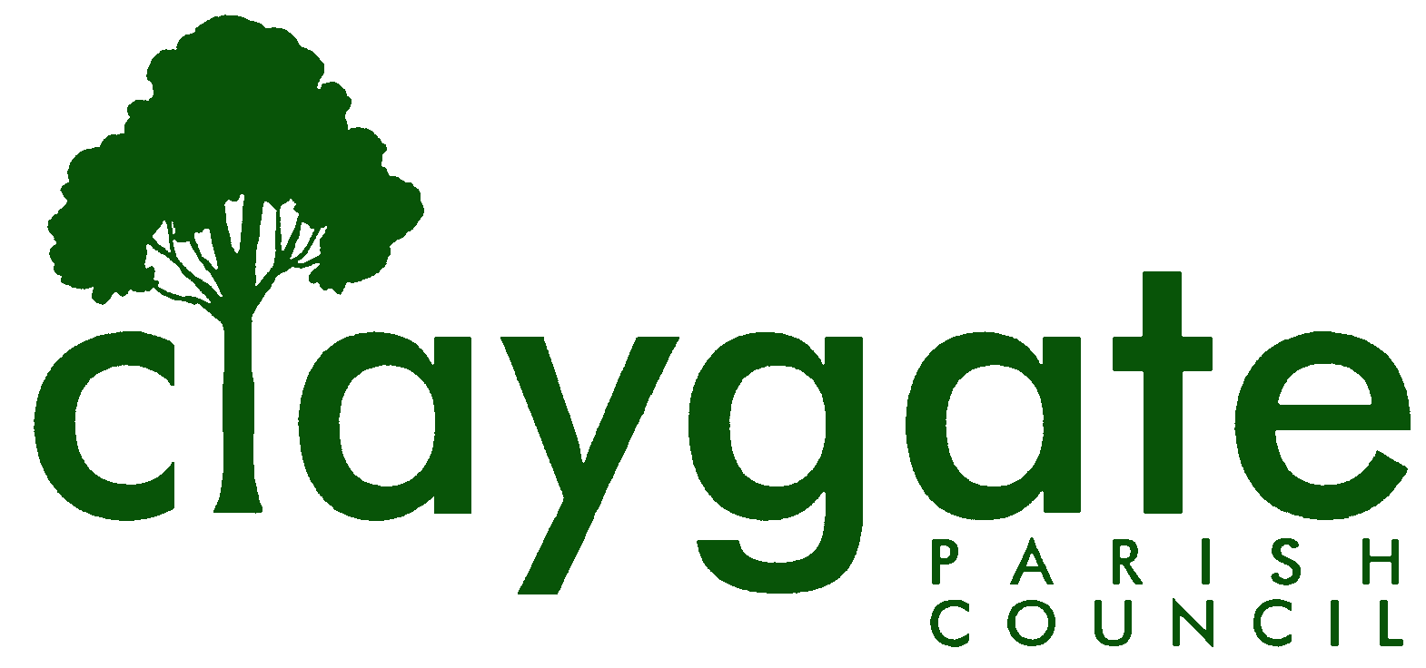
Dawn Lacey – Parish Clerk & RFO

Claygate Parish Council

Claygate Village Hall

Church Road

caring for Claygate Village Claygate

Surrey KT10 0JP

Tel: 07741848719

Email: clerk@claygateparishcouncil.gov.uk
Website: www.claygateparishcouncil.co.uk

FINAL
Minutes of the Planning Committee of Claygate Parish Council held on Thursday 7th November 2024 at 7.30pm at Claygate Village Hall, Small Hall, Church Road, Claygate

Present: Cllr Sheppard (Chair), Cllr Holt, Cllr Bray, Cllr Collon, Cllr Herbert,
Cllr Bingham and Cllr Moon
In attendance: Dawn Lacey (Parish Clerk & RFO)
Non-Voting Advisor: John Bamford and John Burns
5 Members of the Public
1. Apologies for absence.
None were recorded
2. Declarations of Interest in items on the agenda.
None
3. Confirm the minutes of the 7th November 2024 Planning Committee meeting.
These were agreed to be correct and signed by Cllr Sheppard
Carried unanimously
4. Review actioning of items from previous minutes and agree any further action required.
All completed
5. Review planning correspondence, notification of applications and outstanding results and agree any action required.
We had questions from members of the public which were answered under this area.

a: A resident had asked about the rules for a Satellite Dish and if it required planning permission.
Cllr Bray and Cllr Sheppard looked into this: dishes up to 1m in diameter do not require permission. Cllr Bray to write back to the Resident to confirm this and advise her to contact Planning Enforcement if she thinks the dish breaches the 1m rule.
ACTION: Cllr Bray
b: A resident asked the following - Has the Planning Committee considered meeting less often?
Cllr Sheppard responded to this and expressed the view that a monthly should and will continue. It makes sense for Elmbridge Borough Council’s Planning Department to receive all our responses together, including reports from our Tree Wardens. Cllr Sheppard reiterated that Major Applications do go to East Area, if CPC objects, but Minor and Householder Applications don’t.
c: A final question was asked by a resident requesting any updates at this time on Crown House and any possible developments
The Council will update the Public as soon as they have solid information
6. Review Report on Applications Decided, and Appeals Lodged and Decided since last meeting and agree any action required.
No action required. The meeting to be held with Paul Falconer from EBC Planning is to be held on Wednesday 13th November at 10am and will review some cases where CPC and EBC have taken different views. The Clerk will confirm this with Paul Falconer
ACTION - Clerk
7. Discuss planning applications from Elmbridge Borough Council (EBC) Weekly Planning Lists (https://www.elmbridge.gov.uk/planning) for the following weeks and agree responses required: w/e 20th, 27th September and 4th October
Please see attached letters to EBC T Plan (Appendix 1)
8. Receive a report on EBC’s East Area Sub Committee Meeting and agree any action required.
The last meeting was cancelled – so nothing to report. The next meeting will be held on Monday 9th December 2024
9. Receive a report on EBC’s Planning Committee Meeting and agree any action required.
The last two meetings were cancelled – so nothing to report. The next meeting was due to be held on Tuesday 12th November but this has also been cancelled
10. To discuss the Status of the Elmbridge Local Plan
It was reported that the Inspector has rejected the plan. Therefore, EBC need to either revise their current plan, for which they have a maximum of 6 months to complete or withdraw this one and start again with a new plan. If they choose the second option, then they will probably have until 2026 (when the current Local Plan expires) to complete this. Clive Thompson from the Housing Working Group attended the meeting and had issued a list of possible sites (including some Greenbelt areas) that may fall under consideration by EBC or by developers. It was noted that inclusion of a site in this list does not imply endorsement by CPC of development there. It was agreed that the Loseberry Farm field(s) next the BT building should be classified as Green, not Grey Belt. It was agreed that CPC need to work very closely with our Ward Councillors. It was agreed that we invite Cllr. Alex Coomes to our next Planning meeting.
ACTION - Clerk
11. Discuss any Communication of Key decisions to residents and agree any action required.
None at this time.
12. To confirm the meeting date of Planning Councillors with Paul Falconer at Elmbridge Borough Council – either Wednesday 12th or Tuesday 19th November.
This was agreed for Wednesday 13th November at 10am, the Clerk to write to Paul to confirm this and then to let the Councillor’s know if it is to be a Zoom or Face to Face meeting
ACTION: Clerk
13. To confirm /discuss the Planning Committee Remit (Appendix 4)
There were some changes suggested by Cllr Collon as below:
B: line 3 I would not insert at the end “as a consultee”. This implies that if we are not a consultee, EBC has no duty to take into account any representations we may make, which is not the case.
F: to not add NB: CPC is not listed as a Consultee and therefore will not be notified of these applications

These changes were agreed by the Planning Committee. This now needs to be updated and taken to a Main Parish meeting to be adopted
This was Proposed by Cllr Sheppard and seconded by Cllr Herbert – carried unanimously
ACTION: Clerk to update with the changes and add to the next Main Meeting Agenda being held on Thursday 5th December
14. Matters for information purposes only
None
15. Date of the next meeting 7.30pm Thursday 5th December 2024, Claygate Village Hall, Church Road, Claygate. KT10 0JP

MEETING: Claygate Planning Council
VENUE: Claygate Village Hall, Small Hall, Church Road, Claygate, Surrey KT10 0JP
DATE: Thursday 7th November 2024
TIME: 7.30pm

Signed: Date:

