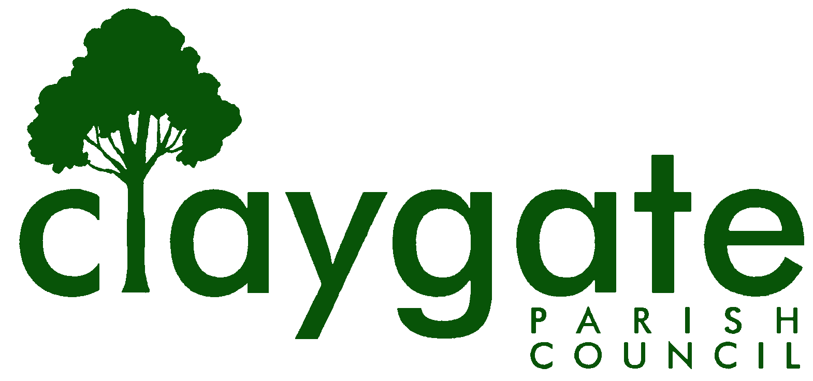
Dawn Lacey – Parish Clerk & RFO

Claygate Parish Council

Claygate Village Hall

Church Road

caring for Claygate Village Claygate

Surrey KT10 0JP

Tel: 07741848719

Email: clerk@claygateparishcouncil.gov.uk
Website: www.claygateparishcouncil.co.uk

FINAL 1st November 2024

YOU ARE HEREBY SUMMONED TO ATTEND

A Meeting of the Planning Committee of Claygate Parish Council will be held on Thursday 7th November 2024 at 7.30pm at Claygate Village Hall, Small Hall, Church Road

The meeting is open to the public and press. A quarter of an hour has been reserved for members of the public to address the Council, for three minutes each, on any subject relevant to the agenda. In order to address the meeting, we would appreciate you contacting the Parish Clerk before 11am on the day of the meeting who will allocate a slot. All meetings will operate to our Privacy Policy which can be found at www.claygateparishcouncil.gov.uk. Doors will open at 7.20pm.

Covid 19

If attendees have any of the main symptoms of Covid-19 and/or have tested positive to Covid prior to the meeting, you should not attend. Please refer to www.gov.uk for full guidelines.

Dawn Lacey
Clerk and RFO

AGENDA

1. Apologies for absence.
2. Declarations of Interest in items on the agenda.
3. Confirm the minutes of the 10th October 2024 Planning Committee meeting.
4. Review actioning of items from previous minutes and agree any further action required. (Appendix 1)
5. Review planning correspondence, notification of applications and outstanding results and agree any action required.

6. Review Report on Applications Decided, and Appeals Lodged and Decided since last meeting and agree any action required. (Appendix 2)
7. Discuss planning applications from Elmbridge Borough Council (EBC) Weekly Planning Lists (https://www.elmbridge.gov.uk/planning) for the following weeks and agree responses required: w/e 11th, 18th, 25th October and 1st November (Appendix 3)
8. Receive a report on EBC’s East Area Sub Committee Meeting and agree any action required.
9. Receive a report on EBC’s Planning Committee Meeting and agree any action required.
10. To discuss the current Status of the Elmbridge Local Plan
11. Discuss any Communication of key decisions to Residents and agree any action required.
12. To confirm the meeting date of Planning Councillors with Paul Falconer at Elmbridge Borough Council – either Wednesday 12th or Tuesday 19th November.
13. To confirm /discuss the Planning Committee Remit (Appendix 4)
14. Matters for information purposes only.
15. Date of the next meeting 7.30pm Thursday 5th December 2024, Main Hall, Claygate Village Hall, Church Road, Claygate KT10 0JP

MEETING: Claygate Parish Council
VENUE: Village Hall, Small Hall, Church Road, Claygate, Surrey KT10 0JP
DATE: Thursday 7th November 2024
TIME: 7.30pm

APPENDICES

APPENDIX 1: Actions from the previous meeting

APPENDIX 2: Review Report on Applications Decided, and Appeals Lodged and Decided since last meeting and agree any action required.

APPENDIX 3: Discuss planning applications from Elmbridge Borough Council (EBC) Weekly Planning Lists (https://www.elmbridge.gov.uk/planning) for the following weeks and agree responses required:

APPENDIX 4: Planning Committee Remit

