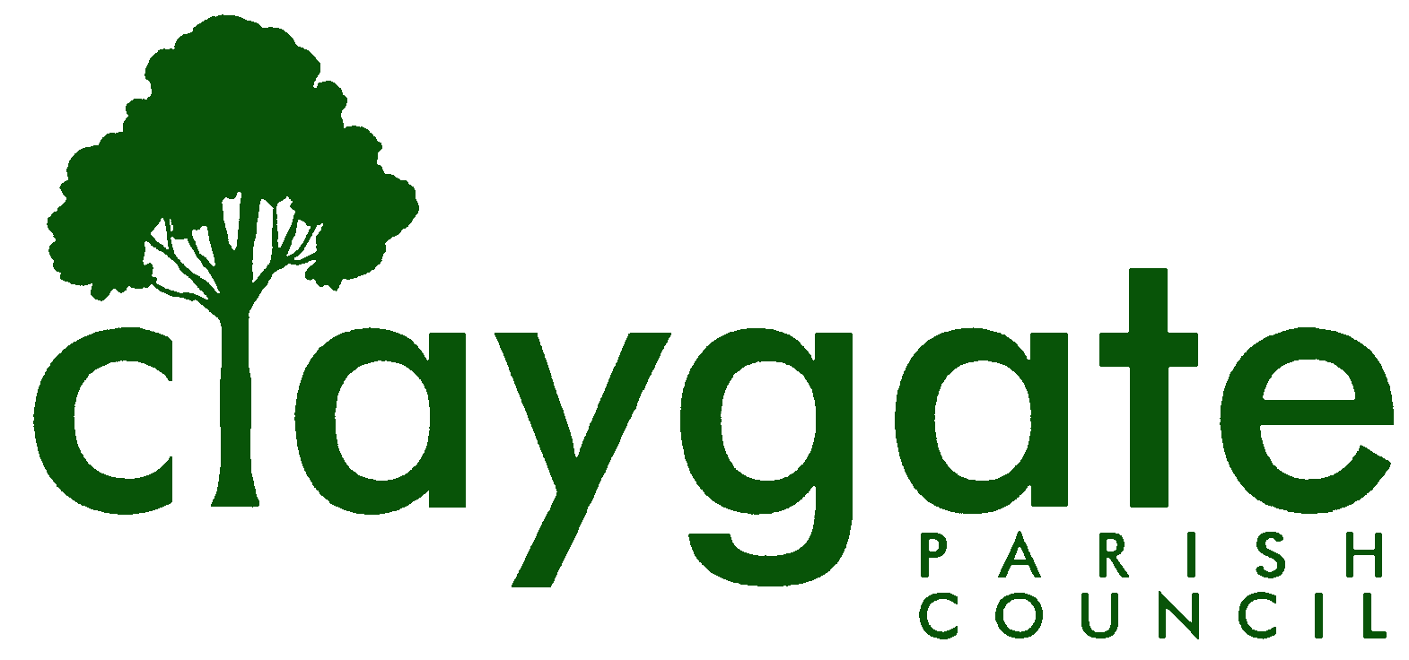

Dawn Lacey Clerk & RFO

Claygate Parish Council

Claygate Village Hall

Church Road

caring for Claygate Village Claygate

Surrey, KT10 0JP

Tel: 07741848719

Email: clerk@claygateparishcouncil.gov.uk
Website: www.claygateparishcouncil.co.uk

FINAL 18th June 2026
Minutes of the Claygate Parish Council Planning Meeting held on Thursday 18th June 2026 at 7.30pm at Claygate Village Hall, Small Hall, Church Road, Claygate
Present: Cllr Sheppard, Cllr Collon, Cllr Collon, Cllr Burns and Cllr Ellis
In attendance: Dawn Lacey (Parish Clerk & RFO).
SCCllr Andy Burton, Cllr Bray, Cllr French and 11 members of the Public.
1. To accept apologies for absence.
Apologies were received from NVA John Bamford and NVA Vanessa Relleen.
2. To Elect a Chairman for the ensuing year.
Cllr Collon proposed Cllr Sheppard as Chairman for the ensuing year. This was seconded by Cllr Burns and carried unanimously.
3. To Elect a Vice-Chairman for the ensuing year.
Cllr Collon proposed Cllr Ellis as Vice-Chairman for the ensuing year. This was seconded by Cllr Sheppard and carried unanimously.
4. To propose Vanessa Relleen, John Bamford and Douglas Edwards as NVA’s for the ensuing year.
Cllr Collon proposed Vanessa Relleen, John Bamford and Douglas Edwards as NVAs and this was seconded by Cllr Sheppard. Carried unanimously.
5. Declarations of Interest on Items in the Agenda.
Cllr Sheppard and Cllr Ellis confirmed that they are residents of Raleigh Drive which is being discussed under Item 13 on the agenda.
Cllr Collon confirmed that he is neighbour for one of the Planning Applications.
6. To confirm the minutes of the Planning Meeting held on Thursday 14th May 2026.
These were agreed to be a correct account and were signed and dated by the Chairman Cllr Sheppard.
7. To review actions from the previous meeting held on Thursday 9th April 2026.
All completed.
All new Actions from this meeting attached (Appendix 1)
8. To answer any questions from members of the Public.
No request for public speaking had been received by the Clerk.
9. Review planning correspondence, notification of applications and outstanding results and agree any action required.
Residents had reported that the protected Oak Tree at 31 Stevens Lane may have been poisoned, a view endorsed by Vanessa Relleen. Suzanne Parkes had been alerted, as had Cllrs Coomes and Marshall.
10. To Review Report on Applications Decided, and Appeals Lodged and Decided since last meeting and agree any action required.
No issues arising.
11. To Discuss planning applications from Elmbridge Borough Council (EBC) Weekly Planning Lists for the following weeks and agree responses required: w/e 8th , 15th, 22nd, 29th May and 6th and 13th June 2026.
Please see attached to T-Plan (Appendix 2)
12. To receive any updates on the proposed Hook Park Development and agree any action required.
The case Officer at Elmbridge has advised as follows:-
“All relevant highway authorities – SCC, London-based and national, are now working with the Applicant to resolve the matters of concern. There are also other matters in addition to transport and highways that need to be addressed prior to determination. The Applicant is due to submit the updated and additional information, expected within the next couple of months, which we will re-consult on for 30 days once received. Please note that this might be during the summer holidays, however we have no control over this.”
The RBK draft Local Plan has now gone to Council for approval. It designates the Hook Park site as suitable for release from the Green Belt.

13. To receive any updates on the Raleigh Drive Development and agree any action required.
Douglas Edwards reported on the current status of consultation with Thames Water. Full report attached (Appendix 3)
14. To update on the Report of the Meeting held with the Crown Estate
We have not heard whether the Crown Estate have authority to proceed with fuller public consultation prior to an outline application. See Appendix 4 for notes of the meeting with the Crown Estate.
15. To discuss CPC’s working relationship with Save Claygate’s Green Belt
The meeting received members of the Save Claygate Green Belt Group who gave an update on where things are currently. They have a working Committee which has a very diverse mix of members. Their petition currently stands at about 1700 signatures. They also have a Stall booked at the Claygate Flower Show. Cllr Collon commented on how impressed he was with the Group and that he is really happy to be working with them.
It was proposed that CPC (not just the Planning Committee) form a working party to work together with the Save Claygate Green Belt Group
This was proposed by Cllr Burns and seconded by Cllr Sheppard – carried unanimously
Cllr Ellis, Cllr Burns, Cllr Sheppard, Cllr Collon and NVA Douglas Edwards all volunteered to be part of the Working Party.
16. To Receive a report on EBC’s East Area Sub Committee Meeting and agree any action required.
Cllr Herbert confirmed that the next meeting will be held on the Wednesday 27th July 2026. Nothing else to report at this time.
17. To Receive a report on EBC’s Planning Committee Meeting and agree any action required.
Cllr Herbert confirmed that the next meeting will be held on the Wednesday 27th July 2026. Nothing else to report at this time.
18. To update on the progress on implementing GovAssist and agree any action required.
Cllr Sheppard reported that he had spent a little more time on GovAssist and suggested that other Councillors and the Clerk also take a look. Cllr Sheppard can provide the password for access. Cllr Sheppard commented that the full Planning Module could be useful for major applications but was unlikely to be used for minor householder applications.; the basic Planning module cannot review individual planning applications. Cllr Sheppard reported that the full Planning module costs £465.00 + VAT. We currently have free access to the basic Planning and other free modules, including Governance, with a limited number of free credits. A full licence for one user at a time is £240.00 + VAT per annum.
There is currently no action to be taken but to keep under review.
ACTION: Cllr Sheppard and all Members/NVAs
ACTION: Clerk
19. To discuss consequences of the proposed amendments to the National Planning Policy Framework and agree any action required.
Cllr Collon confirmed that the CPC comments have been submitted and there are no further actions as this stage.
20. To Discuss any Communication of key decisions to Residents and agree any action required.
It was agreed to add the Claygate Greenbelt email to our Website and any possible plans.
ACTION: Clerk
21. To review any Compliance Issues in Claygate and agree any action required.
Nothing to report.
22. To discuss any Licence Applications.
The Averna in Claygate have applied for some changes in their current licence to stay open later and also to be able to operate as an Off Sales. It was proposed that we object to the extension of the licence as it is near residential properties. It was also proposed that Off Sales should only be allowed with the purchase of take away food.
Proposed by Cllr Sheppard and seconded by Cllr Herbert - carried unanimously.
ACTION: Clerk
23. Matters for information purposes only.
Nothing to report.

24. Date of the next meeting 7.30pm Thursday 23rd July 2026, Claygate Village Hall, Small Hall, Church Road, Claygate KT10 0JP.
MEETING: Claygate Parish Council, Planning Committee.
VENUE: Claygate Village Hall, Small Hall, Church Road, Claygate.
DATE: Thursday 18th June 2026.
TIME: 7.30pm.

Signed: Date:

