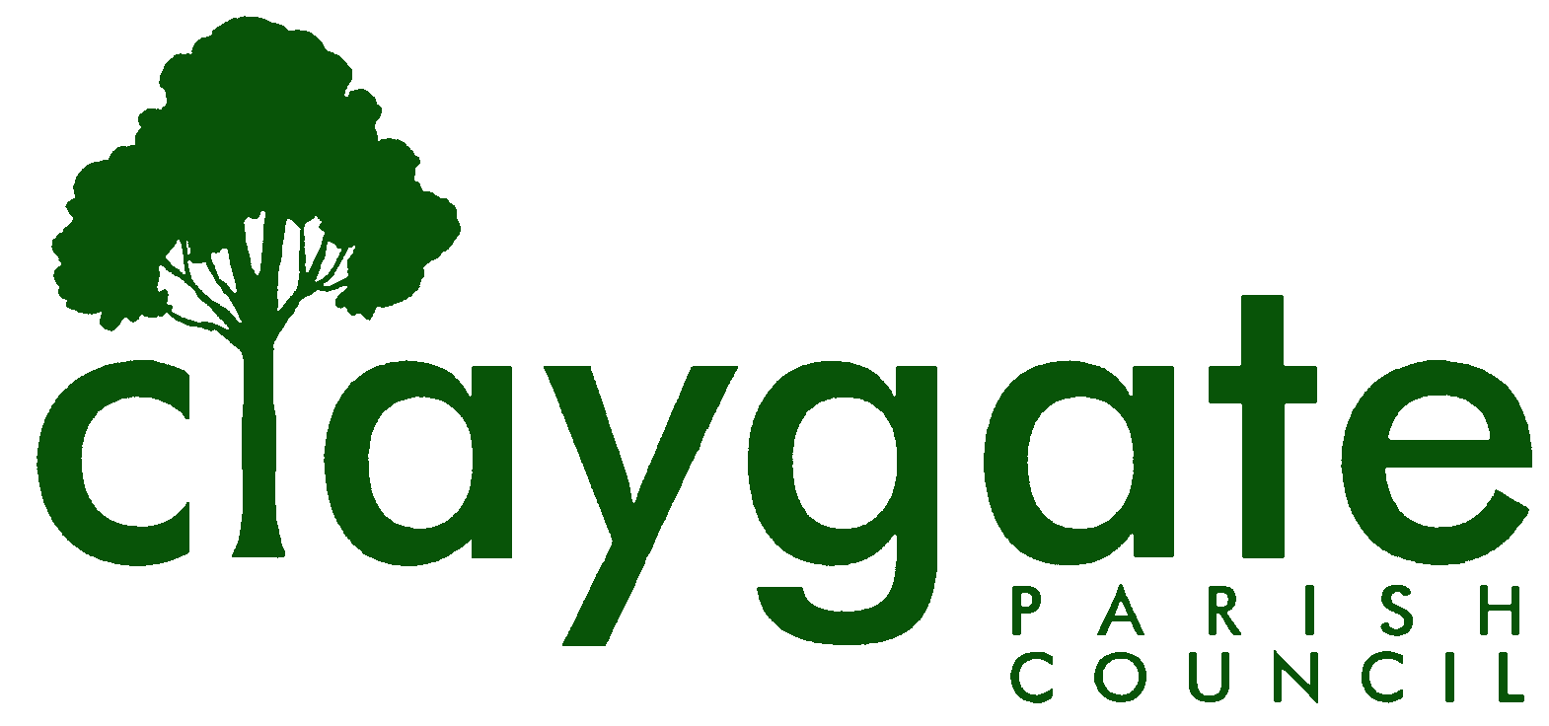

Dawn Lacey Clerk & RFO

Claygate Parish Council

Claygate Village Hall

Church Road

caring for Claygate Village Claygate

Surrey, KT10 0JP

Tel: 07741848719

Email: clerk@claygateparishcouncil.gov.uk
Website: www.claygateparishcouncil.co.uk

FINAL 14th May 2026
Minutes of the Claygate Parish Council Meeting held on Thursday 30th April 2026 at 7.30pm at Claygate Village Hall, Small Hall, Church Road, Claygate
Present: Cllr Bray (Acting Chair), Cllr Sheppard, Cllr French, Cllr Herbert, Cllr Collon, Cllr Bingham and Cllr Ellis
In attendance: Dawn Lacey (Parish Clerk & RFO).
SCCllr Burton and EBCllr Rollings
Non-Voting Advisors: Vanessa Relleen
7 members of the Public.
1 To accept apologies for absence.
Apologies were received from Cllr Holt, Cllr Burns and Cllr Moon
The Acting Chair explained that he was chairing the meeting in the absence of the Chairman, who was recovering from a serious accident, and that the meeting was being recorded to assist with minute-taking.
2 To receive declarations of interest in items in the agenda
No declarations of interest were made in relation to the agenda
3. To confirm the minutes of the Parish Council Meeting held on Thursday 5th March 2026.
The minutes were confirmed as a true and fair record.
These were then signed and dated by Vice-Chairman Cllr Bray.
4. To confirm the minutes of the Extraordinary Parish Council Meeting held on Thursday 9th April 2026.
The minutes were confirmed as a true and fair record.
These were then signed and dated by Vice-Chairman Cllr Bray

5. To review actioning of items from previous minutes and agree any further action required (Appendix 1)
All completed
6. To answer any questions from the general public.
A question was asked regarding the current status of Torrington Lodge Car Park
An update was provided by EBCllr Rollings. who explained that due to Local Government Reorganisation, Elmbridge Borough Council did not expect meaningful decisions before the transition to the new unitary authority on 1 April 2027. Work on Torrington Lodge is therefore paused.
A written update will be provided after 7 May 2026.
The previously suggested public meeting on 19 May will not proceed.
ACTION: Parish Council requested clear written communication to residents explaining the pause and next steps.
7. To Receive a Report on EBC’s Overview and Scrutiny Committee.
A meeting was held on the 26^{th of} March which was mostly on Planning Matters. Nothing specific for CPC
8. To Receive a Report of EBC’s Audit and Standards Committee.
There hasn’t been a meeting since the last Parish Council Meeting.
8. To Receive a Report from the Planning Committee & Agree Appropriate Actions [AAAs].
Recent Elmbridge planning decisions were noted and discussed.
10. To Receive a Report from the EH & T Committee & AAAs.
Cllr Bray reported on the report by the Transport and Parking Advisory Committee on the request for a 20mph speed limit on Hare Lane He proposed that this now be considered at the June EHT Committee meeting and that this be brought forward from 25th to 18th June. This proposal was accepted unanimously.
ACTION: Clerk to change on Website and inform Councillors.

Salt Grit Bins: All bins had been inspected and found structurally sound. Cllr Bray therefore proposed that we abandon the idea of replacing them. This proposal was agreed unanimously. £25 was approved for new signage.

Village Green: The Council approved any unbudgeted expenditure on water incurred due to the prolonged dry weather to protect the investment in new planting.
11. To Receive a Report from the Shops and Businesses Advisory Group & AAAs.
Please see report attached from Leo Tye (Appendix 2)
12. To Receive a Report from the Staffing Committee and AAAs.
Cllr French reported that a 3.3% National Pay award had been proposed by the National Employers for Local Government Services but that this was awaiting final approval. There was provision in this year’s budget to cover this. The increase would be back dated to April.
The Clerk would be commencing her CiLCA training costing £945.
ACTION: Funding approved for Clerk’s training, subject to Clerk confirming attendance at initial session.
13. To Consider the Establishment of a Finance & General Purposes Committee & AAAs.
A proposal to establish a Finance and General Purposes Committee to improve efficiency was agreed. Clerk/Cllr French to draft Terms of Reference.
ACTION: Clerk and Cllr French
14. To Review the Current Situation as Regards TLCP & AAAs.
This Item was covered by Item 6.
15. To receive A Report re: the NAC Meeting on April 28th & AAAs.
Cllr Bray noted that Cllrs Burns, Ellis, French and he, had attended this meeting with SCC & EBC officers responsible for the NAC’s at The Civic Centre on the above date.
He made the following main points: -
a. The single most surprising point to emerge is that the primary focus of the NAC’s is - at least now [ie it may not have been so from the start] - the underprivileged sectors of our communities. They are not intended to be a part of the mainstream democratic processes.
b. The Shadow ESC will vote about their future in September, or thereabouts. There are 3 main possibilities [a] they continue AS IS [b] they continue in some modified form [c] they do not continue
c. The main point we argued for – outside the above points – was that all communities in East Elmbridge [NB: there are 9 RA’s] should have representation on the NAC. The officers we met will consider the extent to which they take this on board, along with other feedback they are receiving.
16. To Discuss How to Process the TPAC Report on 20mph Zone in Hare Lane Through the PC & AAAs.
This Item was covered under Item 10.
17. To Discuss How the Community Asset Transfer Mechanisms [CATMs] Might Be Used to Benefit the Village & AAAs.
Cllr French spoke about the list of assets that are currently owned by EBC and suggested that a case might be made for the CPC to take over some of these Assets. It was agreed to schedule one or more Meetings of Councillors (MoC’s) to discuss the best way forward.
Proposed by Cllr Bray and seconded by Cllr Sheppard – carried unanimously
ACTION: Cllr Bray to schedule Meeting[s] of Councillors.
18. To Review the Situation as Regards the Next EBC/CPC Liaison Meeting & AAAs.
It was noted that a EBC/CPC liaison meeting had been arranged for June 1st at 1130.
19. To Review Proposals Re: Our Grant & CIL Documentation & AAAs.
This item has been deferred to the meeting being held on May 21st, 2026.
20. To Review Our Preparations for the Parish Council Election in May 2027 & AAAs.
A discussion was held on encouraging people to consider standing as candidates for next year’s Parish Council election.
The practical arrangements for the elections in May 2027 were discussed including a possible increase in councillor numbers.
ACTION: Clerk/Chair to write to the Electoral Services Officer to explore options and clarify arrangements. Further discussion to take place outside the meeting.
21. To Review Proposals for Our Meetings Structure for the Rest of 2026 & 2027 & AAAs.
The new meeting schedule was approved for formal adoption at the Annual Meeting.
22. To Receive the Proposed Dates for meetings being held in 2027
The proposed dates were discussed. The Clerk is currently waiting to hear back on Venue availabilities and will report to next meeting being held in May 2026
ACTION: Clerk
23. To Receive Reports from Relevant Cllrs Re Our Plan to Engage with the New Unitary Authority & AAAs.
Cllr Bray invited those Cllrs who had been tasked with various sections of the plan to update the meeting, which they did. However, given the circumstances, he noted his offline proposal that “the plan” should, rather, take the form of a draft agenda for a first meeting with the newly elected ESCllrs and that the coming MoC’s should consider this idea further.
Cllr Bray noted that both the Chairman [Cllr Holt] and he would be away at the time of the coming ESC election and called for a volunteer to draft a first letter to the newly elected ESCllrs, inter alia to congratulate them on their success and propose an early initial meeting between them and us. Cllr Sheppard volunteered to do this, noting that a draft of such letter could also be reviewed by the coming MoC’s
24. To Review and Approve the Following Council Policies: Risk Management Policy & Assessment, Privacy Policy, Dignity at Work Policy, Equality & Diversity Policy,

The following policies were approved
Privacy Policy
Dignity at Work Policy
Equality and Diversity Policy

Proposed by Cllr Bray and seconded by Cllr Sheppard – carried unanimously
The Risk Management Policy needs redrafting, and it was agreed that Cllr Sheppard would do this and present at the May meeting.
Proposed by Cllr Bray and seconded by Cllr Ellis – Carried unanimously.

25. To Receive the Financial Report including Expenditure to 31st March and Approve any Adjustments to the 25/26 Budget Allocations and the Council’s Earmarked Reserves.
These were agreed to be correct as to the 31^{st of} March 2026.
Proposed by Cllr Bray and seconded by Cllr French – carried unanimously.
26. To approve and sign off the February and March 2026 Reconciliations
These were checked and agreed to be correct and then signed and dated by Vice-Chairman Bray and the Clerk.
27. To confirm the date for the Internal Audit with Simon White.
The Clerk confirmed that she was meeting with Simon White on Tuesday 12th May and would report on the Internal Audit report back to the meeting in May 2026.
ACTION: Clerk
28. To Review the Year-end Financial Position & AAAs.
It was agreed that this would be carried over to the meeting on May 21st, 2026.
29. To Review the 2026/27 Budget Allocation & AAAs.
It was agreed that this would be carried over to the meeting on May 21st, 2026.
30. To Receive an Update on the Progress of the New Website and AAAs.
Cllr Bingham confirmed that the website was almost ready to go live and this would happen by the 19^{th of} May. She requested the final payment to be made to Zonkey. This was agreed.
Proposed by Cllr Sheppard and seconded by Cllr Bingham – carried unanimously.
Action: Clerk
Cllr Bingham spoke about training for the new site for uploading data etc. Cllr Bingham to contact Zonkey about a date and time for this to happen and for who would attend this training. It was agreed that the Clerk must have the training.
Proposed by Cllr Bray and seconded by Cllr Sheppard – carried unanimously.
ACTION: Cllr Bingham
A vote of thanks to Cllr Bingham for all her hard work on the Website was proposed and carried unanimously.
31. To Receive a CIL application from the Claygate Recreation Ground Trust & AAAs
Following the above from CRGT, Councillors requested more information on the CIL application before they were prepared to authorise any grant. This application to be brought back to a future meeting.

32. To discuss the recent email regarding The BBC’s Repair Shop on the Road and the Fountain on the Green in the Village and AAAs.
A discussion was held on this and agreed that this could be a really great idea. The Clerk to email back regarding this.
ACTION: Clerk
33. Date of the next meeting which will be held at 7:30pm on Thursday 21st May 2026 at Claygate Village Hall, Church Road, Claygate.

MEETING: Claygate Parish Council.
VENUE: Claygate Village Hall, Small Hall, Church Road, Claygate.
DATE: Thursday 30th April 2026
TIME: 7.30pm

Signed: Date:

