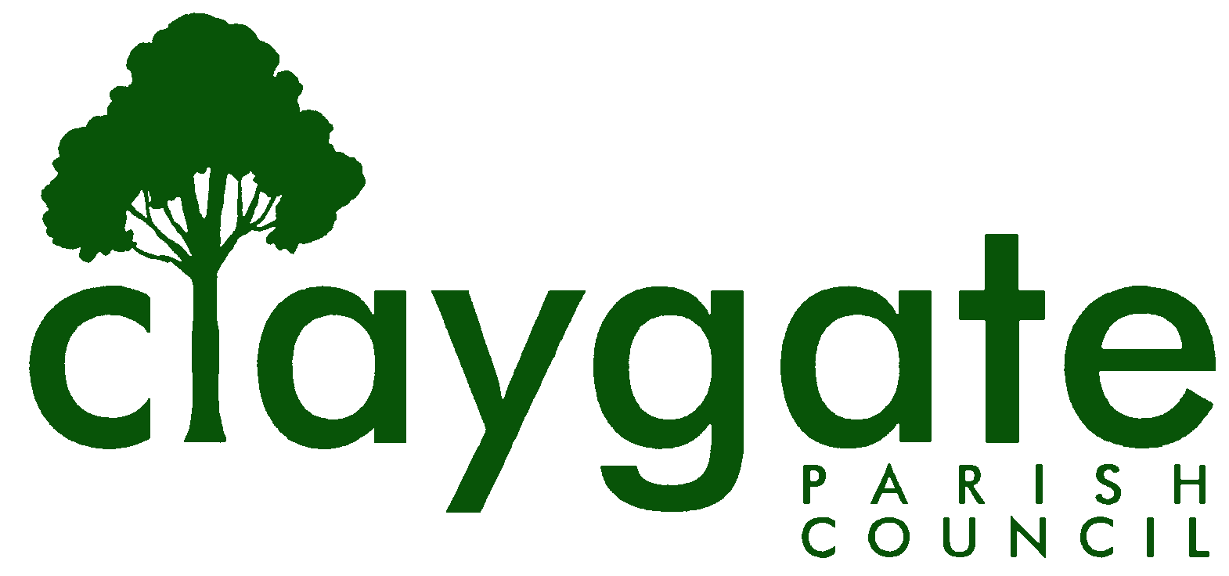
Dawn Lacey – Parish Clerk & RFO

Claygate Parish Council

Claygate Village Hall

Church Road

caring for Claygate Village Claygate

Surrey KT10 0JP

Tel: 07741848719

Email: clerk@claygateparishcouncil.gov.uk
Website: www.claygateparishcouncil.co.uk

Final 23rd June 2026

Minutes of the Environment, Highways and Transport Committee of Claygate Parish Council held on Thursday 18th June at 8.30pm at Claygate Village Hall, Small Hall, Church Road, Claygate

Present: Cllr Bray (Chair), Cllr Holt, Cllr French, Cllr Burns and Cllr Herbert
In attendance: Dawn Lacey (Parish Clerk & RFO)
Non-Voting Advisor (NVA): Mark Tymeniecki,
6 Members of the Public
1. Apologies for absence.
Apologies from Cllr Bingham.
2. To elect a Chairman for the ensuing year.
Cllr Burns nominated Cllr Bray for Chairman. This was seconded by Cllr French and carried unanimously.
3. To elect a Vice-Chairman for the ensuing year.
Cllr Bray nominated Cllr Holt for Vice-Chairman. This was seconded by Cllr Burns and carried unanimously.
4. To Re-appoint Vanessa Relleen, Simon Hope and Mark Tymeniecki as N-VAs for the ensuing year.
Vanessa Relleen, Simon Hope and Mark Tymeniecki were nominated by Cllr Bray to continue as NVA’s for EH& T. This was seconded by Cllr French and carried unanimously.
5. Declarations of Interest on Items on the Agenda.

None.

6. To confirm the minutes of the meeting held on Thursday 9th April 2026

The minutes of the meeting held on 9th April 2026 were approved as a correct record. These were proposed by Cllr Bray and seconded by Cllr French and carried unanimously. They were then signed and dated by the Chairman.

7. To report on the actions from the previous meeting.

All completed

8. To discuss any recent correspondence received and agree any appropriate action.

Cllr Bray reported on the external correspondence he had conducted since the last EHTC meeting in April. A full list is attached (Appendix 1).

9. To discuss the emails received on the 5^{th of} May re Blocking HGVs from the Village.

It was agreed that more research was needed on this matter, and that Cllr Burns would do that

Proposed by Cllr Bray and seconded by Cllr Herbert. Carried unanimously.

10. To answer any questions from Members of the Public.

None

11. To receive a report from SCCllr Andy Burton

Cllr Bray had circulated SCCllr Burton’s report, which he had received earlier in the day, noting the significant number of matters addressed (Appendix 2)

SCCllr Burton had additionally wanted it noted that a path in Arbrook Woods had been improved and the snagging of recent double yellow line painting work was in hand

Cllr Bray to write to SCCllr Andy Burton regarding the CIL requirements for the Wingham Walk paper to clarify which CIL source he had in mind.

ACTION: Cllr Bray

[Post-meeting: SCCllr Burton noted he has Strategic CIL in mind, ie not CPC CIL]
12. To Consider Whether to Recommend the TPAC Report Re: 20mph in Hare Lane to the Parish Council for its Consideration
A resident of Hare Lane confirmed that the neighbours of Hare Lane disagree with the report and will attend the meeting on 25th June regarding this.
It was proposed that the full document should now been taken to Full Council for discussion.
Proposed by Cllr Bray and seconded by Cllr Herbert. Carried unanimously.
13. To Receive a Report from Cllr Bray Re: Actions Taken Re Matters Raised at The Annual Parish Meeting of March 19th
Cllr Bray noted the following: -
- Oaken Lane Road Safety – the Speedwatch Team will continue to monitor matters.
- Blocked Footpath [NW corner of The Parade, adjacent Barclays Bank] – he and SCCllr Burton had visited the site, and noted the issue. SCCllr Burton [& EBCllr Coomes, possibly?] to affix notices to offending cars, when spotted
- Milbourne Lane/Copsem Road junction – junction outside the remit of CPC. No action to be taken.
- White Lines – Stevens Lane/Common Road – in hand, with SCC
- Parking Restrictions [30 minute bays] – a matter for the TPAC group to consider, and report upon at August meeting.
- Church Road/St Leonards Road Roundabout – SCCllr Burton and he had visited the site and could see no fault with the signage. No further action.
- Cycling Provision – defer to August meeting
- Potholes – residents to be advised to self-report, using FixMyStreet
- Red Lane Safety – on-going, as between SCCllr Burton and PCllr Burns
J. Blue Heart Verges – He had confirmed that our HGS contractor would perform a “clear-away” cut in September at no additional cost. This was deemed reasonable.

14. To Receive an update from Cllrs Burns & Holt re: Pursuit Of Items in Cllr Holt’s “Wingham Walk” Paper
Cllr Holt confirmed that this is ongoing and will report back at the next meeting.
ACTION: Cllr Holt
15. To Receive a Speed Watch Report
Mark Tymieniecki reported on the past months Speed Watch Report which is attached to these minutes (Appendix 3).
He was pleased to be able to say that speeding continues not to be a significant issue in the village.
Cllr Bray asked Mark specifically to thank his team members for their work.
16. To Receive an update from the Transport and Parking Advisory Committee.
In the absence of Simon Hope his report is attached to the minutes (Appendix 4)
17. To receive an update on the Bench on the Parade.
Cllr Holt confirmed that the Bench has now been installed on The Parade. There have been lots of positive comments from Claygate residents. The Clerk gave the Plaque in Mark’s memory to Cllr Holt, and she will be organising this to be added to the Bench.
ACTION: Cllr Holt
18. To Receive a Report from Southwestern Railway.
The Chair reported that SW Trains had been in touch to say that, while funding has not yet been secured for the scheme, it is still in their programme of work for FY 26-27. It was agreed that we need to maintain our pressure on this issue. Clerk to leave on the agenda for the time being.
ACTION: Cllr Bray and Clerk
19. To receive updates from the Cllrs who monitor the HGS Sites
It was confirmed by Councillors that the Sites are looking good.
Cllr French commented on the Troughs by the Foley that the flowers were looking pretty dead. Considering they have only just been installed this is not good enough. Cllr French to draft a letter to EBC for Cllr Bray to send to EBC about this.
ACTION: Cllr French
Cllr Bray to ask Paul Quinnen to quote for Steel Edging around the Flower Bed on the Coverts/Foley Triangle Blue Heart Site.
ACTION: Cllr Bray
20. To discuss the renewal of the Highways Garden Contract.
It was noted that the Contract expires in April 2027, and that we should not have a repeat of what happened last time round when the contract was not renewed on time. Accordingly, Cllr Bray asked for any suggestions to improve the current contract to be sent to him by the end of June and he will report back at the next EH&T meeting in August.
ACTION: Councillors and Cllr Bray
21. To discuss a possible, Keep Right/One Way Sign outside the Hub on Elm Road.
Cllr Bray had received a letter from Katie Holmes at the Hub asking if it would be possible to get better signage outside the Hub as drivers still often go the wrong way and she is concerned for safety. Cllr Burns to go and look at the Site and report back.
Proposed by Cllr Bray and seconded by Cllr French. Carried unanimously.
22. Update on the Grit Bins
Cllr Bray reported that he had visited all the Grit Bins and was in the process of getting labels for them. They do not need replacing.
ACTION: Cllr Bray
23. Matters for Information Purposes Only
Cllr Bray had received correspondence from a Claygate Resident asking why the CPC support the Blue Heart Scheme. Cllr Bray had written back to him giving only his own views on this.
ACTION: Cllr Bray
Cllr Bray confirmed that the large Bins outside the new Green Grocers on the Parade had now been removed.
21. Date of Next Meeting: Thursday 20th August 2026, Claygate Village Hall, Small Hall, Church Road, Claygate – 8.30pm

Signed: Date:

