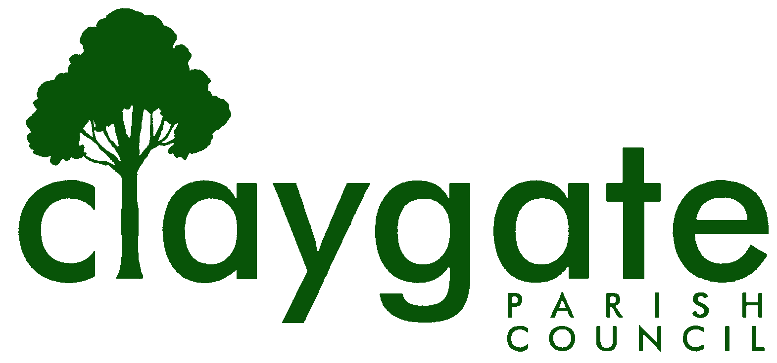

Dawn Lacey Clerk & RFO

Claygate Parish Council

Claygate Village Hall

Church Road

caring for Claygate Village Claygate

Surrey, KT10 0JP

Tel: 07741848719

Email: clerk@claygateparishcouncil.gov.uk
Website: www.claygateparishcouncil.co.uk

DRAFT 27th May 2026
Minutes of the Claygate Parish Council Meeting held on Thursday 21st May 2026 at 7.30pm at Claygate Village Hall, Main Hall, Church Road, Claygate
Present: Cllr Holt, Cllr Sheppard, Cllr Collon, Cllr Bray, Cllr Burns, Cllr French, Cllr Bingham, Cllr Ellis and Cllr Herbert
In attendance: Dawn Lacey (Parish Clerk & RFO).
EBCllr Marshall and 5 members of the Public.

1. To confirm Declarations of Interest of Current Councillors
It was confirmed that all Declarations of Interest were up to date.
2. To accept apologies of absence.
Apologies were received from Cllr Moon.
3. To Elect a chairman for the ensuing year.
Cllr Burns was proposed by Cllr Herbert and seconded by Cllr Bray – Cllr Burns accepted - This was carried unanimously.
4. To Receive the Chairmans Declaration of Acceptance.
Cllr Burns signed and dated the Declaration of Acceptance, and this was counter signed by Dawn Lacey, Clerk & RFO. Cllr Burns then took over to Chair the meeting.
Cllr Burns proposed a vote of thanks to Cllr Holt for everything she had achieved over the last 2 years. This was seconded by Cllr Bray and carried unanimously.
5. To Elect a Vice-Chairman for the ensuing year.
Cllr Sheppard was proposed by Cllr Bray and seconded by Cllr Collon – This was carried unanimously. Cllr Sheppard accepted the nomination

6. To Receive Declarations of Interest on the agenda.
None
7. To confirm the minutes of the Council Meeting held on Thursday 30th April 2026.
There being no changes, Cllr Bray (who had chaired this meeting) signed and dated the minutes.
8. To Review Actions from the meeting held on 30th April 2026.
Item 20 – Electoral Services for the 2027 election – Ongoing
Item 32 – Repair shop – Ongoing
All other Actions were completed
9. To answer any questions from the general public.

Questions from the floor raised the inaccuracy of Thames Water records on the flooding events at Raleigh Drive and their own knowledge of the foul and storm water drainage system. Consequently, inaccurate information was provided to the planning authority to consider a planning application for 80 dwellings. The Parish Council will continue to press for accurate information to be provided to Elmbridge BC prior to a full application.
10. To confirm the Remit of the Parish Council.

This was confirmed as correct and is now live on the new Parish Council Website

11. To confirm the Parish Council’s Vision for Claygate.

Due to Elmbridge Council having still not approved their Vision, we are unable to complete ours at this time. This is to be left on the agenda for the next meeting.

ACTION: Clerk
12. To review delegation arrangements to committees, employees and other local authorities.

These were reviewed.

13. To confirm the Terms of Reference (Remits) of the Planning, Environment, Highways & Transportation, Finance & General Purposes and Staffing Committees.
There are a few small changes to be made on these.
EH&T – to delete item 4 point 5 from the Remit
Proposed by Cllr Bray and seconded by Cllr Sheppard – carried unanimously.

Planning – to delete D 5 – last two lines
Proposed by Cllr Sheppard and seconded by Cllr Collon – carried unanimously.

All 4 were then proposed en bloc by Cllr Sheppard and seconded by Cllr Holt – carried unanimously.

ACTION: Clerk to make the minor changes

14. To appoint members to the following committees.
a) Environment, Highways & Transportation Committee
Cllr Burns, Cllr Bray, Cllr French, Cllr Bingham, Cllr Holt and Cllr Herbert
b) Planning Committee
Cllr Burns, Cllr Sheppard, Cllr Collon, Cllr Ellis and Cllr Herbert
c) Finance and General Purposes Committee
Cllr Burns, Cllr French, Cllr Holt, Cllr Bray, Cllr Sheppard and Cllr Herbert
d) Staffing Committee
Cllr Burns, Cllr French, Cllr Bray and Cllr Sheppard
To update the Governance Structure once all the above Committees have nominated their Chairman and Vice-Chairman and confirmed any NVA’s
ACTION: Clerk
15. To review and adopt the Council’s Financial Regulations, Members’ Code of
Conduct, CIL Policy and Guidance, Grants Policy and Guidance, Risk Management Policy

The Risk Management Policy, CIL policy and Small Grants Policy were deferred to the next Main Council Meeting.

The Code of Conduct Policy was adopted.

The Councils Financial Regulations were agreed in principle but need to be re-visited once the Standing Orders are completed and updated

All the above Proposed by Cllr Sheppard and seconded by Cllr Bray – carried unanimously.
16. To review arrangements including any charters and legal agreements with other local authorities, not-for-profit bodies and businesses.

It was proposed by Cllr Bray and seconded by Cllr Herbert to adopt all – carried unanimously.

17. To review representation on, or work with, external bodies and arrangements for reporting back.

a: EBC’s Overview & Scrutiny Committee – Cllr French and Cllr Bray to report
b: EBC’s Audit and Standards Committee – Cllr Herbert to report
c: EBC’s Planning Committee – Cllr Ellis to report
d: EBC’s East Area Planning Committee – Cllr Herbert to report

it was agreed to also add EBC’s Cabinet Meetings to the above – Cllr French and Cllr Bray to report

18. To Agree Monitoring Arrangements for the Developing East Surrey Council and AAA’s.

Cllr Sheppard and Cllr French to continue with the NAC’s – Neighbourhood Area Committee.

19. To review the Council’s Asset Register

The new bench on the parade is to be added to the Council’s Asset Register. Cllr Bray and the Clerk to organise a time to re-visit and check all the assets. Clerk to send the correct copy of the Asset register to Councillors.

ACTION: Clerk and Cllr Bray

20. To confirm arrangements for insurance cover in respect of all insured risks.

Again, to contact the Insurance Company to add the new bench to our Insurance Policy as soon as possible.
ACTION: Clerk

21. To review the Council’s and/or Staff Subscriptions to other bodies.

The Council currently has ongoing Subscriptions with SALC / NALC and SLCC – these have all be renewed for 2026/2027

22. Review of the Council’s expenditure incurred under s137 of the Local
Government Act 1972.

Nothing to report.

23. To receive a verbal report on the Year End Financial Accounts from the Clerk. (Appendix 2)

It was agreed that the Clerk would contact EBC regarding the Overpayment of CIL monies.
ACTION: Clerk

24. To update and approve the Parish Council bank accounts online signatories,
invoice signatories and signatories of monthly bank reconciliations and approve the appointment of the Clerk as Service Administrator to all bank accounts.

It was agreed to remove Cllr Moon from the signatories and replace him with Cllr Burns. Cllr Holt, Cllr Collon and Cllr Bray to continue as signatories and the Clerk to continue in the appointment as Service Administrator to all bank account.

Proposed by Cllr Bray and seconded by Cllr Sheppard – carried unanimously

25. To receive an update on the Internal Audit.

The Clerk confirmed that the Internal Audit had taken place with Simon White and she would now be starting to organise the AGAR Year End

ACTION: Clerk

26. To confirm the dates and times of meetings of the Council and its Committees for the year ahead.

The dates for 2027 were confirmed, some venues still to be booked as the Village Hall is unavailable. Clerk to report back at next meeting on this.

ACTION: Clerk

27. To review the current position as regards Torrington Lodge Car Park and AAA’s.

The meeting scheduled for May 19th was cancelled and there is currently a hold on any further work on this at present. Councillors have a meeting with EBC on the 1st June where they will ask further questions.

ACTION: Councillors

28. To review the opportunities for Community Asset Transfers prior to 1 April and AAA’s.

It was proposed to express informal interests in the following Assets. Claygate Day Centre, Allotments, Both Car Parks and the Community Mini Bus. We need to draft something immediately and get it onto our Social Media platforms and Website to engage the residents of Claygate. Cllr Collon will draft this and send to Cllr Holt and the Clerk

ACTION: Cllr Collon, Cllr Holt and the Clerk

It was proposed to write immediately to EBC also regarding this
Proposed by Cllr Sheppard and seconded by Cllr Bray – Cllr Holt abstained from voting. All other Councillors were in agreement

ACTION: Cllr Sheppard

29. To review the Unitary Engagement plan and AAA’s

Cllr Sheppard to contact our two new East Surrey Shadow Councillors Burton and Coomes to arrange a meeting.
ACTION: Cllr Sheppard

30. To review plans for the Parish Council Election in May 2027 and AAA’s.

The Clerk confirmed that there is nothing to report at this stage.

31. Matters for information purposes only.

EBCllr Mary Marshall kindly offered to pay for the Plaque in memory of Mark Sugden for the new bench. The Clerk to liaise with her on this.

ACTION: Clerk

To find out if the new bench needs treating with any special wood materials.

ACTION: Cllr Holt

The Clerk confirmed that she had booked a stand at the Claygate Flower Show on the 11^{th of} July and will be in touch with Councillors in the next couple of weeks to see their availability

ACTION: Clerk

32. To confirm the date and time of the next meeting which will be held on Thursday 25th June 2026, at the Claygate Village Hall, Small Hall, Church Road, Claygate and 7.30pm

Signed: Date:

