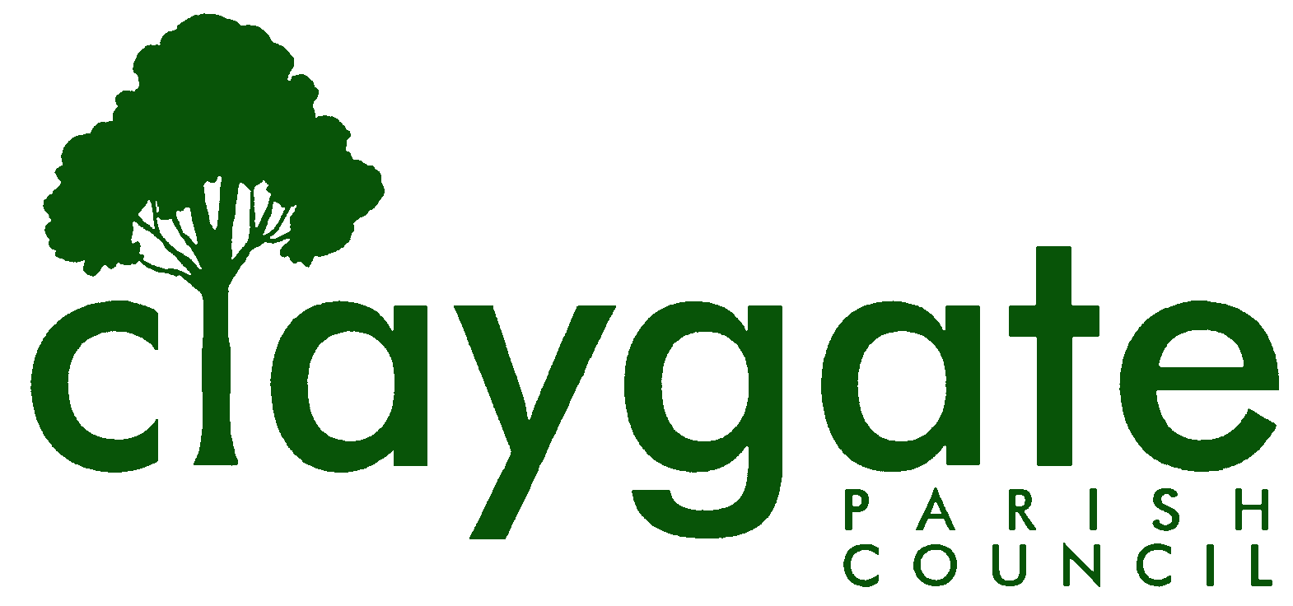

Dawn Lacey Clerk & RFO

Claygate Parish Council

Claygate Village Hall

Church Road

caring for Claygate Village Claygate

Surrey, KT10 0JP

Tel: 07741848719

Email: clerk@claygateparishcouncil.gov.uk
Website: www.claygateparishcouncil.co.uk

FINAL 1st January 2026

YOU ARE HEREBY SUMMONED TO ATTEND

A meeting of the Claygate Parish Council will be held on Thursday 8th January, Claygate Village Hall, Small Hall, Church Road, Claygate

The meeting is open to the public and press. A quarter of an hour has been reserved for members of the public to address the Council, for three minutes each, on any subject relevant to the agenda. In order to address the meeting, we would appreciate you contacting the Parish Clerk before 11am on the day of the meeting who will allocate a slot. All meetings will operate to our Privacy Policy which can be found at www.claygateparishcouncil.gov.uk. Please note that the capacity of the hall is limited, and places will be allocated on a first come first served basis. Doors will open at 8.20pm.

Covid 19

If attendees have any of the main symptoms of Covid-19 and/or have tested positive to Covid prior to the meeting, you should not attend. Please refer to www.gov.uk for full guidelines.

Dawn Lacey
Clerk & Responsible Financial Officer

AGENDA

1. To accept apologies for absence.
2. To receive Declarations of Interest on the agenda.
3. To confirm the minutes of the Parish Council Meeting held on Thursday 20th November 2025.
4. To review actioning of items from previous minutes and agree any further action required (Appendix 1)
5. To answer any questions from the general public.
6. To Receive a Report of EBC’s Overview and Scrutiny Committee.
7. To Receive a Report of EBC’s Audit and Standards Committee.
8. To Receive a Report from the Planning Committee.
9. To Receive a Report from the EH & T Committee.
10. To Receive a Report from the Shops and Businesses Advisory Group.
11. To Receive a Report from the Health and Wellbeing and Leisure Advisory Group.
12. To Receive a Report from the Transport and Working Advisory Group.
13. To approve the Budget and set the Precept for 2026/2027 (Appendix 2).
14. To approve and sign off the October, November and December 2025 Reconciliation (Appendix 3).
15. To review and approve the Quarterly accounts (Appendix 4).
16. To review and approve the quote for the works for the trees on Meadow Road.
(Appendix 5).
17. To approve the wording on the Bench on the Parade.
18. To agree the provider for update of the CPC Website so the work can be completed and to appoint a Project Manager to liaise with the chosen company to implement the site.
19. To review and approve the Governance and Advisory Groups.
20. To discuss the 20mph TRO’s and agree any action required.
21. To update and discuss the approval of the Licence for the Cloudy IT Systems
22. To Receive and update on the Subject Access Request and Agree any Action Required.
23. To discuss the 365 Microsoft Licensing that the Clerk and Councillors are currently accessing and agree any steps to make sure everyone is set up correctly.
24. Matters for Information Purposes only
25. To confirm the date and time of the next meeting which will be held on Thursday 5th February 2026. Claygate Village Hall, Small Hall, Church Road, Claygate

MEETING: Claygate Parish Council
VENUE: Claygate Village Hall, Small Hall, Church Road, Claygate
DATE: Thursday 8th January 2026
TIME: 8.30pm

