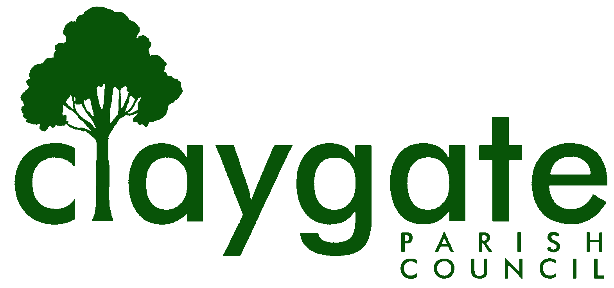
Dawn Lacey – Parish Clerk & RFO

Claygate Parish Council

Claygate Village Hall

Church Road

caring for Claygate Village Claygate

Surrey KT10 0JP

Tel: 07741848719

Email: clerk@claygateparishcouncil.gov.uk
Website: www.claygateparishcouncil.co.uk

DRAFT 27th April 2026

Minutes of the Staffing Committee of Claygate Parish Council held on Thursday 23rd April, Claygate Village Hall, Small Hall, Church Road, Claygate

Present: Cllr French, Cllr Sheppard, Cllr Burns

In attendance: Dawn Lacey (Parish Clerk & RFO)

1. Apologies for absence.
Apologies were received from Cllr Bray.
2. To approve the minutes of the previous meeting held on Thursday 12th February 2026.
These were agreed to be a correct copy and were signed and dated by the Chairman.
3. To review the actions from the previous meeting.
All completed.
4. To Elect a Vice-Chairman of the Staffing Committee.
Cllr French proposed Cllr Burns who accepted,
Proposed by Cllr French, seconded by Cllr Sheppard – carried unanimously.
5. To discuss the Clerks Pay increase in line with the 2026 National Pay Award and agree appropriate actions.
A 3.3% Pay rise has been proposed by the National Employers for Local Government services but as this is yet to be confirmed this will be held over to the next meeting. Clerk to add to the next Staffing Committee Meeting.
ACTION: Clerk

6. To discuss the Clerk commencing CILCA training.
A discussion was held with the Clerk about starting her CILCA training this May – there is a cost of £945.00 for this and it runs over a 6 month period.
The Clerk is more than happy to start her training and will look at both the SALC and SLCC dates and days to see which one would work better. Cllr French will propose this for approval at the Main meeting being held on the 30th April.
ACTION: Cllr French and Clerk
7. To review the Staffing Remit and agree and action required.
There were a couple of small changes which need to be made to the Remit. This will then be brought to the Annual Meeting in May for approval. It will be requested that the Remit allow delegated authority for expenditure on staff training.
ACTION: Clerk
8. To Confirm the meetings in 2026
It was discussed that the next meeting would be held on Thursday 29th October 2026 at 7.30pm before the EH&T Committee Meeting. This needs to be added to the Website.
Proposed by Cllr French and seconded by Cllr Burns – carried unanimously.
ACTION: Clerk.
9. To discuss the meetings for 2027 to added to the list of dates currently waiting for approval.
It was agreed to add Thursday 25th February and Thursday 21st October 2027 to the list of dates requested for Staffing meetings.
Proposed by Cllr French and seconded by Cllr Sheppard – carried unanimously.
ACTION: Clerk

MEETING: Claygate Parish Council Staffing Committee
VENUE: Claygate Village Hall, Small Hall, Church Road, Claygate, Surrey KT10 0JP
DATE: Thursday 23rd April 2026
TIME: 7.30pm

Signed: Date:

