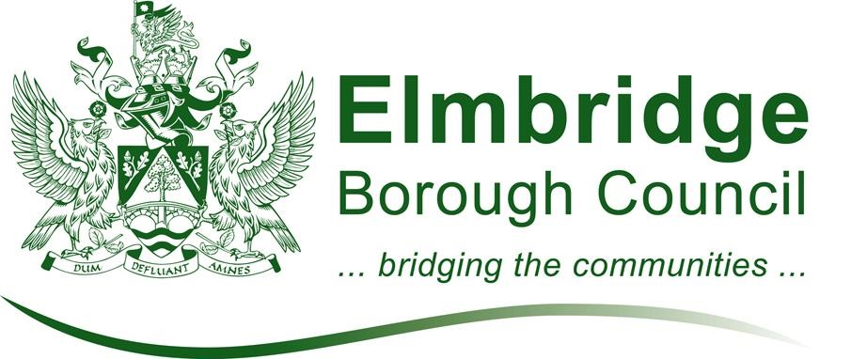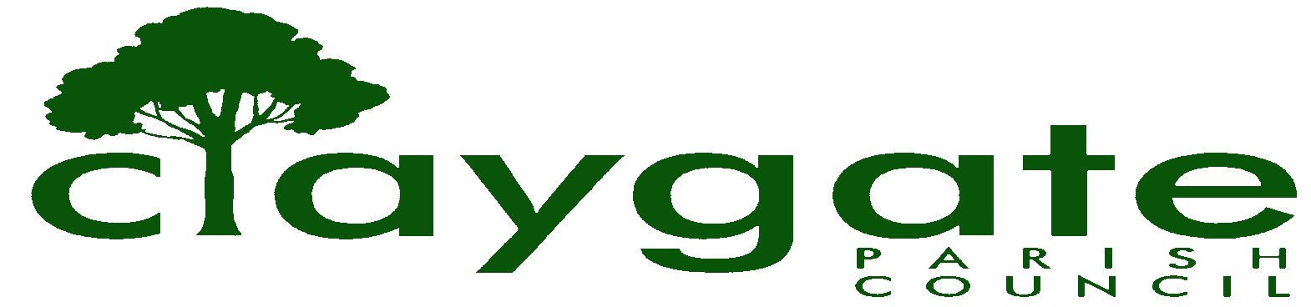

caring for Claygate Village

PARISH CHARTER

Between Elmbridge Borough Council and Claygate Parish Council

- This Charter is intended to indicate the ways in which the Borough Council and Parish Council would wish to maintain and develop their partnership relationship. Whilst each authority will use its best endeavours to comply with the principles and practices described in this Charter, each authority reserves the right to manage its affairs in accordance not only with the law but also in whatever it considers to be the best interests of its area and to depart from these principles and practices if that is considered to be the best course of action at any time. The Charter does not apply to services provided to individual persons or any matters that are subject to a statutory complaints procedure.

- Elmbridge Borough Council and Claygate Parish Council have agreed to publish this Charter to set out how they aim to work together across the two tiers of local government.

- The County, Borough and Parish Councils are partners in a multi-tiered system of democratically elected local government that exists for the benefit of the people of Surrey. The Councils represent all levels of democratic local government, and are keen to see efforts made to improve their system of local democracy and to encourage greater public participation in local affairs. The Councils are keen to promote transparency and sustainability, and accordingly references in the Charter to sharing information and/or documentation will wherever practical be fulfilled by placing information in the wider public domain and through electronic information sharing.

- Elmbridge Borough Council acknowledges and recognises that Parish Councils are a part of the grass-roots level of local government. By working with them Elmbridge aims to act in partnership with local communities, whilst balancing the needs of the whole borough. Councils in each tier have statutory responsibilities entrusted to them by Parliament for the whole community within their area.

- In their role as democratically accountable bodies, Parish Councils offer a means of shaping the decisions that affect their communities. They offer a means of decentralising the provision of certain services and the revitalisation of local communities. In turn they recognise the role of District Councils and the equitable distribution of services they must provide.

- This Charter reflects the increased importance attached by Central Government to partnership working.

- Elmbridge Borough Council will involve the Parish Council in the preparation and delivery of the Community Strategy, specifically as to how the Community Strategy affects the parish of Claygate.

- Liaision meetings between Elmbridge Borough Council and Claygate Parish Council will ordinarily be scheduled twice a year (subject to business) and may additionally be held when issues of mutual importance require discussion.

- Elmbridge Borough Council will administer Parish Council elections/referenda and will run elections and referenda as efficiently as possible, in consultation with the Parish Council. The Returning Officer will give as much notice as possible of anticipated increases in the costs of running Parish Council elections

- Elmbridge Borough Council will consider the views the Parish Council has expressed when making a decision that affects the local community. Subject to the statutory provisions for confidentiality under the Local Government (Access to Information) Act 1985 as amended, the need for commercial confidentiality and the requirements of contractual arrangements, the Borough Council will provide, at the request of the Parish Council, information relating to activity by the Borough Council which may affect the Parish Council.

- Elmbridge Borough Council will not always be able to follow the Parish Council’s express wishes, because of their responsibility to the wider community and greater range of considerations to be taken into account. In such cases, the Borough Council will aim to give full consideration to the views of the Parish Council which will be reported to the decisionmaking body before a decision is made. Where a decision-making body or Chief Officer or his/her representative acting under delegated powers, has made a decision contrary to representations made by the Parish Council, the Parish Council will be given a copy of the committee report (subject to Access to Information provisions).

- To help achieve the objectives laid down by this Charter, liaison and consultation will be further developed at parish level through regular meetings and consultation at officer level, individually or through working parties and groups. Elmbridge Borough Council will provide a liaison
officer to act as a point of contact for the Parish Council, and ensure they are signposted appropriately.

- Claygate Parish Council will send all agenda and minutes to Surrey County Council, Elmbridge Borough Council and relevant ward councillors, who will be given the opportunity to speak at Parish Council meetings on matters of mutual interest, if they request to do so and as agreed with the Chairman of the Parish Council.

- When Elmbridge Borough Council consults with the Parish Council it will provide sufficient information to enable an informed view to be expressed, and give adequate time to respond, in accordance with statutory requirements where appropriate.

- Elmbridge Borough Council will supply to the Parish Council, free of charge, a limited number of Council publications as are reasonably requested, where these are not available online

- Elmbridge Borough Council and the Parish Council will aim to acknowledge emails and letters within three working days and to answer all correspondence within ten working days.

- Both authorities have adopted Member codes of conduct.
Representatives of the Parish Council have seats on the Audit and Standards Committee and where required on the Audit and Standards Sub-Committee.

- Should the Parish Council wish to take on delegated responsibility for service delivery and having regard to equitable respective levels of council tax and relevant statutory provisions, Elmbridge Borough Council will consider this and the consequential funding arrangements, where they are mutually beneficial. Where it is considered that the proposed course of action does not represent best value, is not in the interests of the whole Borough or is either inappropriate or impracticable, Elmbridge Borough Council will, in consultation with the Parish Council, consider alternative solutions to encourage more local level input into service delivery.

- Elmbridge Borough Council will, where practical, offer Claygate Parish Council access to certain support servicesat a mutually agreed price. Assistance will be offered where appropriate and practicable to do so, in identifying and helping to meet the training needs of the Parish Council. The Borough Council will arrange for the Parish Clerk and Parish
Councillors to participate in relevant training courses run by the Borough. The Borough Council will according to the exigencies of the services it provides give advice, assistance and support upon request, assuming such a request to be reasonable in nature and that it cannot be met by the Surrey County Association of Parish and Town Councils.

