FILE NOTE – MEETING OF CROWN ESTATE & CPC Raleigh Drive, 10:00, 26th May 2026
Present:
Jo Bradford – Director of Community Engagement, CE
Iona Cameron – Manager, Strategic Land Programmes, CE
Richard Pia – Associate Director, Camargue Group Ltd [PR Consultancy]
Anthony Sheppard - CPC
Gil Bray - CPC

- Introductions
- Effect of CPC Annual Meeting on AS & GB roles noted
- CE noted its origins in the 1700s, whereas now a commercial entity responsible to The Treasury, obliged by Act of Parliament to seek best value for money in all its dealings

- JB
- CE has contacted 3 x Ward Cllrs. 1 has replied to them, 2 have not.
- Tenant of land recently died, survey work done
- A “Countryside Park-led” development looks very much on, with a [final?] Go/No Go decision to be made later this week, following which we will start with postings, and engagement events
- We know about the Hare Lane situation
- [map – Appendix 2 - tabled]
- “no more than 500 houses”, hopefully retain the farm buildings [marked * on map], mixed densities, countryside park at southern end [NB 1: a rough boundary [A] hatched, making the park much bigger than suggested in the SCGB post [Appendix 1], though boundary not defined], also a North-South “bio-barrier” between the west of the development and Arbrook Lane [NB 2: a rough area [B] hatched, though not defined. But, not as per the SCGB post]

- IC
- CE has been promoting this site to EBC for years
- The “walk to station” provision has definitely helped
- EBC had earmarked the site for “early release from Green Belt”

- AS
- Questions:-
Flood plain? Access? [Points 1 & 2, marked on map. With special issues at [2]] Infrastructure? There may be an ancient hedgerow in the Country Park area, possibly associated with the boundary of the Emley Bridge Hundred. ? How will the country park increase bio-diversity as compared to the existing pasture land? Is this just a first phase?

- IC
- All very early stages. No work has yet been done on access or infrastructure. Flood plain may provide exciting opportunities for bio-diversity – our experts at Windsor are excited by the possibilities
- No knowledge of ancient hedge [CPC to supply more info]
- Not a 1st phase, the countryside park will prevent that – provision for 30 year minimum

- GB
- Interested to know all your land holdings within C. area, up to 1 km, given the loose definition of “walking distance” in the proposed revision to the NPPF.

- IC
- We will provide a map showing 2 x circles centred on Claygate Station [800m & 1km], showing all our holdings
- We’ve been promoting 4 sites to EBC for many years
  - This one
  - Land known as Horringdon Farm, behind Coverts Road [taking no action on this currently]
  - Blundell Lane, Oxshott
  - Dane’s Lane [?Cobham?]

- Concluding Remarks
- AS explained CPC’s policy of opposing development on Green Belt as being detrimental to the character of the village. Emphasised the particular value of the Loseberry Farm fields as breaking up the built form of Claygate and providing those arriving at the station with a sense of rural space.
- GB advised CE to research the TLCP issue, to see what the Claygate community is capable of, when roused
- GB explained that CPC appreciated that the CE team were doing their job and thanked them for taking the time to talk to us, in spite of the strong opposition their proposals aroused.
- JB – please delay your first public post till we have the Go/No Go [i.e. there might be no point]

9. Actions
JB to provide a soft copy of the site sketch plan.
JB to provide a map with 2 x circles centred on Claygate Station [800m & 1km], showing all CE holdings.
AS to provide more information on ancient hedgerow

Appendix 1 – Save Claygate Green Belt Post

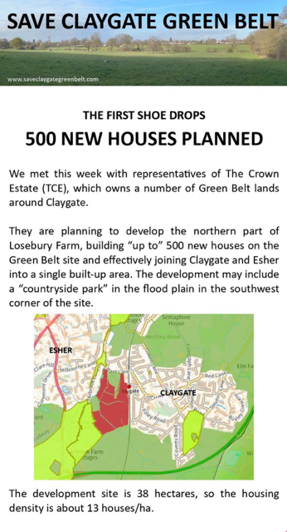
Appendix 2 – CE’s Map of Its Land Holding To The West of The Station

