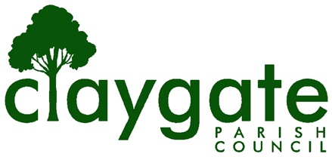

Claygate Parish Council Remit
Introduction
This document outlines Claygate Parish Council’s view of its key priorities in relation to the community it serves.
What does a Parish Council bring to Claygate?
- Dedicated local focus, without involvement of national political parties;
- Funding via the precept for Claygate’s exclusive benefit, plus access to other sources of funds, both public and private;
- A forum for involving more residents in consulting and taking action to improve village quality of life;
- An officially recognised focus for representing Claygate in discussions at Borough and County level and an effective local partner for the Borough and County Councils.
Core Mission
The overall aim of Claygate Parish Council is to:-
Constantly to strive to improve the quality of life for all those who live, and work, in Claygate, whilst preserving its unique character as a warm, caring and sustainable village community.
Core Values
In discharging this mission, the Parish Council will –
- Act as a democratically accountable focus of Claygate opinion on matters to be decided at County/Borough level, as well as by the Parish Council;
- Be responsive to the village community and easily contactable;
- Ensure that village life is –
  - sustainable, in terms of human resources, finance and environmental considerations;
  - safe and secure.
The Parish Council’s Vision for Claygate is of a village with the following characteristics:-
- A community which no one wants to leave;
- A warm sense of community which welcomes newcomers;
- A high degree of participation in voluntary activities, civic, philanthropic, cultural and spiritual;
- A range of social, cultural and sporting activities to suit all ages and tastes;
- Successful conservation of rural features and period architecture;
- A vibrant business community and local shopping centre.
Implementation
The Parish Council will review this document every four years in the first year of the Council cycle. At least once a year, the Council will review what new proactive initiatives it should be undertaking in the light of changes in its operating environment, community needs and available resources.
Proposed new initiatives will be tested, among other criteria, for compliance with the Council’s agreed
Mission and Values.
July 2012 approved Nov 2012
July 2020 Reviewed. No amends
Sept 2020 Web Accessibility reviewed
May 2021 reviewed. No amends.
July 2023 reviewed. No amends
Published
March 20, 2026
Last Updated
March 20, 2026

